C211 Readings & Assignments: Week 1

Week 1 Reading
Complete the following reading early in the week:
- Week 1 online lectures
- From your course Textbook, Storyboards, Motion in Art, read the following chapter:
*Chapter 35: Portfolios

Week 1 Assignments Overview
Assignment Summary: Week 1 | Due Date
Assignment 1: Biographical Sketches | Week 1, Day 2
Assignment 2: Discussion Questions | Week 1, Day 2
Assignment 3: Synopsis Exercise | Week 1, Day 4
Assignment 4: Thumbnail Storyboard Exercise | Week 1, Day 6
Remember that all assignment details can be found on the assignment pages located throughout the week. Go to those specific pages for direction on how to complete each individual assignment.

Course Overview
Welcome to Storyboard Rendering for Animation. This course will be your next step to master one of the most dynamic and exciting realms of modern society THE ART OF STORYTELLING!
Starting with the pre-historic cave dwellers, storytelling has evolved over thousands of years. What began as simple words spoken to a small audience grew to performing in front of crowds, and eventually expanded to become a form of mass communication reaching billions of people simultaneously. Today storytelling is the core of the vast entertainment industry, which provides an enormous array of programs for various cultures around the world. Modern technology makes it possible to create convincing visual renditions of practically anything the human mind can imagine, but the success or failure of any production always depends on the strength of the story and the way it is told.
The primary objective of this course is to help you become a good storyteller through effective visual imagery, creative writing, and basic acting skills precisely by creating effective storyboards.
To acquire the skill of storyboarding, you'll have to move out of your comfort zone. That is move from the audience to the director's chair where the objective is to entertain and not be entertained. Entertaining others is not always fun, but the more you apply what you learn, the better you'll become. The better you become, the more fun you will have. The rewards will be numerous!
Throughout this course, you'll learn to perfect your craft by applying proven methods, styles, and techniques. You'll also learn to recognize these techniques in the work of others by developing awareness about the reasons for using them. Let's begin our journey!
Learning Outcomes:
• Establish a clear understanding of why storyboards are necessary and how to tell a story effectively
• Integrate the principles of composition
• Distinguish when to use still versus motion imagery
• Apply principles of visual literacy of design
• Design for specific delivery methods
This course takes a hands-on approach, enabling you to apply what you learn in lectures and case studies to a series of storyboard exercises and projects. You'll study the development of storyboards and identify the different types of storyboards and formats. You'll understand how to use your basic drawing skills, knowledge of color theory, and the history of various art movements to develop storyboards. You'll also study cinematic techniques and director cues so you can speak the language of filmmakers.
The ability to work effectively with thumbnail sketches serves as a catalyst for reaching your maximum potential. Taking the thumbnail to a rough storyboard, then to clean up, final color, and a complete animatic with soundtrack brings you into the real world of the storyboard artist, from a director's perspective.
Confidence in your design and creative ability can be measured in how well you present an idea. The storyboard "pitch" in the sixth week is your chance to excel in the art of storytelling as you communicate your ideas to others.
You will face challenges in each step of this six-week course. Upon completion, you'll have the knowledge and self-confidence to go out into the working world, taking a portfolio of samples along with you.

Why Do I Need a Storyboard?
Suppose you were to board a commercial airliner and discover that the pilot didn't think it was necessary to file a flight plan or consult with the air traffic controllers. A voice over the intercom might say something like, "We are going to just sort of fly around awhile until we see something familiar." Although this hypothetical situation is unlikely to occur, it does highlight the need to put a plan into place to prevent disaster. Similarly the main purpose of storyboarding is to create a plan that will solve problems before they occur in full production.
Therefore the goal of any storyboard artist is to see problems before they occur and suggest solutions for them. Your creativity helps with that. Creative people are basically problem solvers. This is evident from the fact that the seven astronauts chosen out of the hundreds who applied for the Apollo space program by NASA had some creative talent in music, acting, or art. During their mission, when an emergency limited their oxygen supply, the astronauts used creative thinking to save their lives by fashioning a filter out of whatever was available in the spacecraft.
Animation is a pure form of problem solving. From the moment an idea is conceived, a myriad of problems arise. From the first thumbnail sketch to the last rendered frame, each problem encountered must be eliminated in order to complete the final project. The core structure and framework of any animated production is established in the storyboards. It is within this phase that many problems are identified and solved. A storyboard becomes the blueprint for the production creating one mind set for all members of the team similar to the sheet music that makes it possible for an orchestra to play a large symphony in perfect harmony and tempo.
A storyboard provides a virtual think tank, where ideas can be tossed around without encountering major production expenses and issues. It protects all parties involved, assuring that documented steps for approval and sign-offs are in place before the project gets underway.
The storyboard also acts as a base upon which the production budget is established or assures that a project can be completed within a budget that may have been established previously. Either way the financial obligation for an animated project must be worked out in order to be sure that production costs are identified, tracked, and controlled. A general budget by the frame or by the running second can be recognized, but the actual calculation of estimated costs must be built around the storyboard. When a production is being considered or approved and is underway, it is imperative that financial issues are properly dealt with. A production that winds up behind schedule or is drastically over budget can have catastrophic results. Therefore, don't take it lightly-it has happened before and it could happen to you!

Compositional Elements of a Storyboard
It is difficult to list the capabilities required to become proficient at storyboarding in order of importance because each element involved is crucial to the process. We will be going into great detail on the artistic aspects of storyboarding later in this course. At this point, we are going to direct our attention to drawing, storytelling, and directing.

Drawing Skills
As emphasized in the previous courses, basic drawing skills are essential to be a successful storyboard artist. Recall that you started out by learning to draw basic shapes such as spheres, cones, cylinders, and rectangles and then relied upon these shapes as the structure for more complex work. Build on the skills acquired so far. From the storyboarding perspective you should become proficient at drawing hands and feet - especially the hands, as they are an important part of expression. Make an effort to minimize detail in the ears and hair, which only need to be indicated. Learning to draw what you see vastly improves the ability to draw what you imagine.
You can read a great example of artistic competency in the story of the "9 Old Men." They knew nothing about animation but they used their superb artistic skills to produce the first full-length animated motion picture, Snow White. (Read The Illusion of Life, Disney Animation, by Frank Thomas and Ollie Johnston.)
In addition to people who could draw well, Walt Disney had an ace up his sleeve—he knew how to tell a story!
Click to Explore: Storyboard samples - http://www.paulpower.com/movie.html

Storytelling
Pioneers in the animation industry soon discovered that there was much more to this art form than just drawing. The art of telling a story is a strong skill of an accomplished storyboard artist. So how does someone become proficient at this? Start with the basics.
Although the concepts of storytelling are covered in detail in other courses like Digital Storytelling, it's worth looking at these concepts here and understanding how these concepts are practically applied.
What is at the very core of good storytelling? It has been described brilliantly in Aristotle's Poetics. Aristotle said, "A good story must have a beginning, a middle and an end." Though simple, it's amazing how many story productions fail because they lack these key ingredients. Bringing this into the modern age of motion pictures, television, and computers can be a little easier if you follow the guidelines shown in the graphic below:
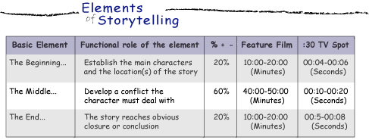
The use of these elements applies to a full-length feature film, a television program, a TV commercial—anything that attempts to deliver an entertaining message. You can also apply them to a scene, as you develop stories within a story. The percent column is only a general idea of the approximate portion of the project dedicated to the elements and should not be taken literally. The same is true of the timing designations in the last two columns, which is merely a rough calculation of the percentages. Keep in mind the fact that these are only guidelines and not rules!
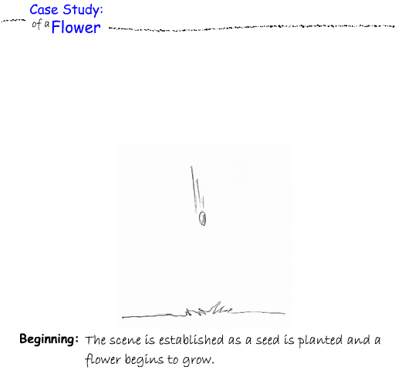
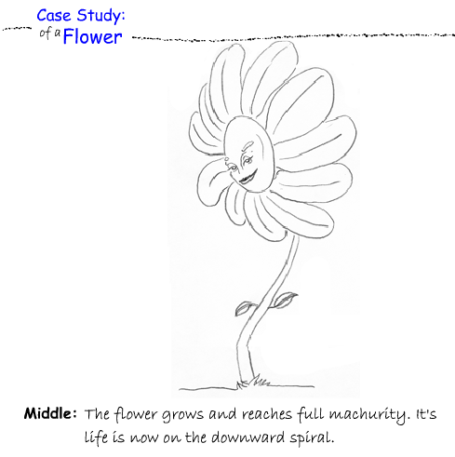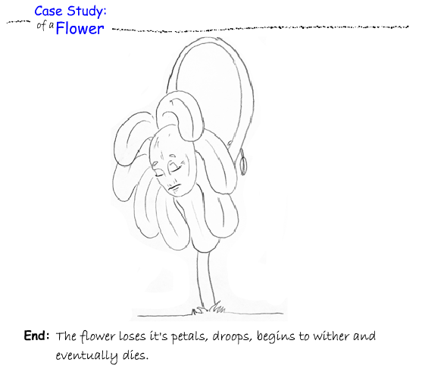

Cinematic Techniques and Direction
Think for a moment of your favorite film or TV show. What was it about a particular film or show that made you sit up and take notice? Did you happen to note who directed the production? If so, do you now keep an eye out for anything new this director creates?
Remember that you are no longer in your comfortable audience chair, but in the director's chair. It is no longer enough for you to say you like a film or you like someone's work—you need to know why. What is it, specifically, about that work that attracted your attention and perhaps inspired you to choose this career path?
Successful directors know how to think like a camera, yet another key element for becoming proficient at storyboarding. As you study the works of those who inspire you, watch what they do with the camera. The positioning of the camera impacts the drama of a scene tremendously. When does the camera cut to a close up, a wide shot, a pan or dolly shot? An extremely low angle shot (worm's eye view) can make a character or location seem overwhelming. A high angle, or bird's eye view, does the opposite by making the character or scene appear less dominant, way below the vantage point of the viewer.
A good director also uses effective timing. Knowing when to cut to a different camera shot, when to dissolve or fade, and when to create follow shots are important aspects of timing that make all the difference. In order to maintain the attention of the audience, the director provides carefully planned out shots that prevent the story from falling flat. So remember to keep the story moving!
How to compose shots: http://www.animationmeat.com/pdf/televisionanimation/brad_bird_on_comps.pdf

The Storyboarding Process
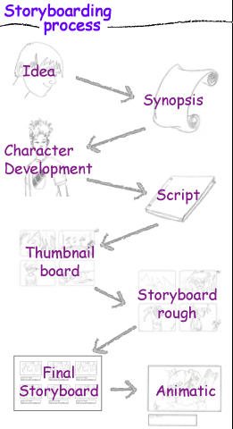
The typical evolution of a storyboard follows a general chronological order something like this:
An idea is formed. The idea is refined and written as a synopsis. Based on the synopsis, character development gets under way. The synopsis and rough characters evolve into a thumbnail board, which is converted into a full-size storyboard rough. Through line art and color, the rough is turned into a final storyboard. In the end product—an animatic—color boards are shot as stills on videotape and matched to a soundtrack with dialogue, sound effects, and a music score.
With all these steps in place and the storyboard signed off at each phase, the production has a better chance of reaching completion with fewer surprises and limited changes. Everyone involved is protected. The finished project will have a much greater chance of meeting the desired objectives that were identified from the very beginning.

Humble Beginnings
To lay the groundwork for the story line, it is best to start small. The story artist writes a synopsis, a brief description of the story, the characters, the location, and other pertinent information. The artist does not spend a great deal of time on the synopsis, so that changes can be made without a lot of expense.

Creating Thumbnail Storyboards
Once the synopsis is approved, you can prepare a thumbnail storyboard (thumbnail board). This is a series of very small, simple sketches of panels that follow the direction established by the synopsis. The drawings do not need to be any more detailed than what you might scribble on a napkin. This rendition is primarily done to plan the scene, establish the shots, and define the approximate positioning of the characters. Like the synopsis, thumbnail storyboards are not labor-intensive; changes can be made easily and quickly. Again, the further a project goes into production, the more expensive changes are to make.
Working small also allows you tremendous latitude in determining the flow of the production you are visualizing. This wide perspective gives you a strategic overview of the work in progress as well as points out any adverse patterns that may be developing along the way.
While making a thumbnail board ask yourself if a better choice of shots might tell the story better. Are there enough panels to tell the story adequately or are there too many? This is the time to follow your gut instincts on the best approach to take, and work fast with the ideas as they come to you. Try not to lose focus of the main message you are trying to convey. Don't get bogged down with drawing; just keep moving with the flow as though it were happening in real time.

Also be sure you are communicating well with your intended audience. Are you going over their heads? Are you being overly simple, too dramatic, or academic? The main purpose of the thumbnail board is to test the waters. It is very simple to eliminate or add panels at this time and you can work as rough and fast as you want.
You may find it necessary on occasion to work up a new thumbnail if the original has been scribbled on enough to make it difficult to read. If this is the case be careful not to lose the spontaneity you had on the original thumbnail board. Once you have it all down, you can move on to drawing it full size but this is the stage for really hammering out an idea until you feel it is on the right track. It is thinking on paper, almost like doing improv with a pencil.
Another effective technique that can be helpful is to photo enlarge the thumbnail sketches to full size for the final boards with the help of copiers that have this capability. This will help you maintain your spontaneity right from the beginning! Try not to lose that.
Each step along the way leads to the next. If it's a bad idea from the beginning it will only get worse as it moves along. Get it right in the beginning. Keep at it until you are confident that the best possible solution has been reached. Garbage in means garbage out.

Creating Rough Boards
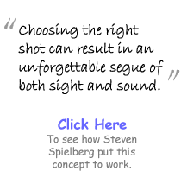
Once the thumbnail is approved it is time to sketch out the rough boards. The majority of storyboard artists work on blank storyboard pages, consisting of two or three panels. Using the thumbnail as a guide, the panels are sketched on the storyboard frames in full size. For production storyboards, the panels need to be numbered, the backgrounds identified, and camera instructions, dialogue, sound effects included at this point. It is at this phase of the process that scenes are timed and documented.

Choosing the Right Shots
While creating the rough boards, it's important to choose the right shots. The novice storyboard artist will usually follow a logical path when directing camera positioning, unless the script demands otherwise. Following the dialogue is generally the best method to take. If the character is speaking, go to a close-up of the face. If the dialogue mentions a particular subject or object, the camera should reveal this to the audience. In time, you will experiment with more creative shots.
It is this type of ingenuity that inspires greatness in others. Our subject may be animation, but we are not restricted to that as our only source of inspiration. You owe it to yourself to study closely the work of great film directors and learn from them. Great directors will tell you that they were inspired by someone else!
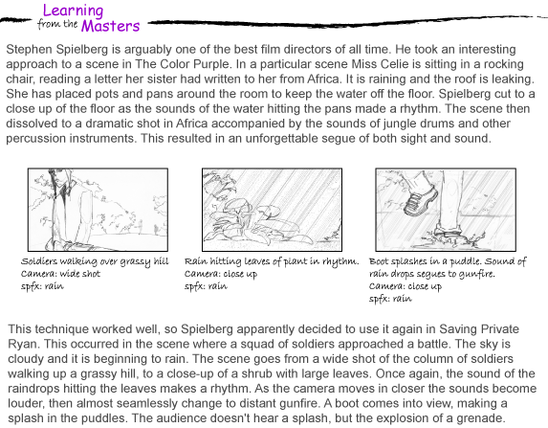

Storyboard Principles and Techniques

The Objective of a Project
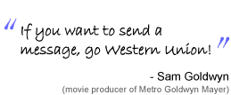
Before setting out on any storyboard assignment, it is important to know exactly what you are expected to accomplish. Though the objective may seem obvious, there may be underlying circumstances that are important for you to know. Remember it doesn't matter how well a storyboard is illustrated or how entertaining the story is if it does not carry the conceived message.
In TV commercials, where target audiences are very specific, it is especially important to understand the objective. A good example of this would be storyboarding a TV spot for a client who manufactures skateboards. You create a concept involving an old man swatting at flies in his kitchen and his microwave explodes. Granted, it may be funny but it would not be very effective in promoting the product because it appeals to the wrong audience. A radical, high-energy approach would be much more effective. Before you develop a concept, you must analyze the audience you are trying to reach and make sure you present a message with the topics the client wants to include.
A scene in a feature film may have wider audiences, but understanding the objective is certainly no less important. It's plain common sense to make sure you have enough background information on a project before going into the conceptual phase.

Developing a Concept
Five Ws: Who? What? When? Where? Why?
The storyboard artist should always be cognizant of five basic questions when it comes to developing a concept. These are commonly referred to as the "Five Ws"—Who? What? When? Where? Why? If the artist does not keep these questions in mind, it is more than likely the concept will be lacking in some way.
Have you ever sat through a lousy movie, play, or TV show and thought "Is this thing ever going to end?" The reason it seems to never end is generally because it never really got started in the first place. The establishing shots, or lack of them, did not answer these questions. Such a treatment leaves the audience more or less dangling and eventually they will probably lose interest. Once this happens, it is difficult to get them back again.

Playing by the Rules
Although animation requires a lot of creativity, you cannot take liberties in two areas - speed and format. Let's see why you need to stick to them. The speed involves play back. A motion picture plays back at 24 fps, video speed plays at 30 fps, etc. The animator must respect this because it would be impossible to arbitrarily change it. Games of course are different but the play speed needs to be conformed to. Next is the format, which deals with the screen sizes and aspect ratios. Motion picture has many variables such as Academy, Cinemascope, etc. with several different ratios. Video format is fairly consistent at 720 x 480 pixels, although Beta formats have a few options to consider. Computer screens are also tied direct to format. At any rate, the animator must commit to speed and format. Once that is decided, it cannot be deviated from. These are the only two hard rules. Every other technique in the creative process is only a suggestion.
But defining standard techniques also limits you sometimes. The moment you think something can only be done one particular way someone will come along, do it differently and make it work. So, when we talk about the principles of storyboarding we are only attempting to identify certain strategies that have proven to be effective. The creative mind excels in doing something unique and for the first time. There is no rulebook, only a glossary.

Developing a Strong Cast of Characters
Character development also involves more than mere artwork. While the visual appearance in the design of a character is important, the operative word here is character. The personality of any character you create must be apparent and in many ways predictable. In the coming lessons, you'll learn proven techniques to animate a character, but giving a character personality is probably most important. You should no longer regard your creations as drawings but as distinctive actors that are a vital part of your cast of performers.
It is important to note that, in some cases, characters are still in the development stage at the time storyboards are drawn. This is an excellent opportunity for you to take a character to the point where you want to take it. In order to build the personality that lies within, you need to act the part of the character as much as possible. So, before storyboarding act out all the scenes. Consider how the character would react under different circumstances. Stay aware of the camera and play to it. Seize the moment and let the character really perform in the storyboard!

Researching the Location and Time Line
Film and television professionals have a lot of expertise. As an animator you are first and foremost a filmmaker—never forget that. The film and video industry utilizes thousands of experts and consultants in a wide range of categories. The storyboard artist must be prepared to fill all of these roles personally. For the purpose of this particular lecture we will talk about the location scout and property master. We'll discuss other roles later in the course.

The Location Scout
In any film production, the location scout must find the ideal setting for the story. Just as the location scout finds the ideal setting, the storyboard artist must create the ideal setting by an exhaustive search of everything available. If your setting is, say an old cabin, you must find out the details such as what part of the world the cabin is located to assure the structure is in keeping with actual cabins in that area. What is the foliage like? What is the prevailing culture? The same questions can be addressed in almost any location involved.
On the other hand, if the location is another planet or universe, the opposite might apply where nothing even remotely familiar is present.

The Property Master
Similarly, in live action production, the property master establishes the time line. The storyboard artist must wear this hat as well. The time line establishes what is in the scene during a particular time period. The artist must identify all props to be included and then consider whether they are appropriate for the period.
If you were doing a period piece during the mid 1940s, a person talking on a push-button phone would look completely out of place. This is an overly simple example of a component of the storyboard process that should always come into play, but you will find that these situations do occur during production.
Weather is yet another consideration. The timeline involves not only a particular time in history, but the time of year as well. What is the season? What would the weather typically be like at that location, during that time of year? What would people wear? How would the buildings be climate controlled?
As you can see, during the conceptual stage of a project, a capable storyboard artist will pay a great deal of attention to detail.

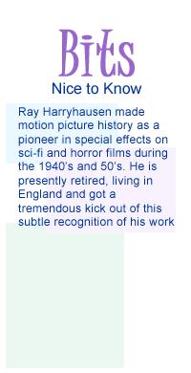
Putting a 'Spin' on the Story

Negative Spin
Samuel Goldwyn, the great movie producer, said that putting a negative spin on a story rarely, if ever works. His opinion was that putting a negative spin on a story means giving it a message that is not directly linked with the main theme of that story. If at all possible, a writer should never allow a story to be compromised by the inclusion of a subliminal message.
The audience should be entertained and amused, never manipulated.

Positive Spin
There are countless films and television programs that show us how to put a positive spin on a story. Disney, for example, has been sneaking characters from older films into their new shows for many years. Belle, from Beauty and the Beast makes a brief appearance in Hunchback of Notre Dame, and Scar, from Lion King, can be seen in Hercules and other films as well. This was a novel idea that allows Disney to showcase big stars. Fans look forward to spotting familiar characters in new releases.
Another example can be the movie Monsters, Inc., in which John Lasseter of Pixar named the local hangout club as Harry Hausen's, which was a tribute to one of the great stop-motion animators of all time. The average audience was not even aware of what was going on but animators truly loved it. This spin did not hamper the storyline, on the contrary, it enhanced the storyline.
Treatments such as this can help make a story more interesting without risking a compromise. It is important, however, to remember that any spin needs to be well thought out and have the full approval of the directors and producers.

Indicating Sound Effects and Cues
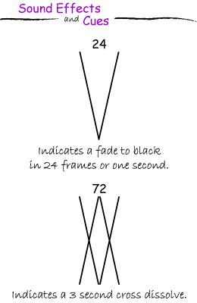
To become an effective storyboard artist, you need to learn to speak the technical terminology, as well as indicate camera cues with symbols. The storyboard artist should be able to convey exactly what is to occur in a scene by designated camera cues. Look at the graphic for an example.
Every frame of a production board must depict what the camera is doing. If the action remains unchanged, the frame is marked as a hold. If the camera angle changes to another scene, it is a cut. Fades, wipes, dissolves, pans, tilts, zooms, and all other camera instructions must be identified and stated clearly.
Therefore if the script calls for a multiplane shot that racks out of focus on level 2, when the lead character says line, then racks back into focus on level 1 when the villain falls over a cliff, the storyboard artist must know exactly what this means and convey it on the boards accordingly.
When preparing boards prior to the soundtrack recording, the artist must add cues where the sound effects (FX) are to occur. The sound FX cues are documented separately from the dialogue to avoid confusion. The storyboard artist must know when sound FX are needed, even if it is ambient noise such as a gentle wind or birds in the distance. Attention to detail is required in every phase of the storyboard process. In other words, you must become fluent in the language of your craft!

Setting Mood with Color, Light, and Shadow
You have already learned in your study of color theory how dominant colors can affect the mood and atmosphere of a scene. The same is true with light and shadow. The storyboard artist must also learn to paint with light and shadow, which is vitally important for establishing the atmosphere that prevails in a scene. Dramatic lighting is most effective in live action. Comic book artists, specializing in science fiction and super heroes owe much of their success to how they have learned to apply this technique in their work.
Hence, the storyboard artist is also a lighting director!

Does it Read… Will the Audience Understand it?
In the final analysis, consider the audience for the proposed script. Is the language appropriate? Is the language too juvenile? Is it overly intellectual? For example if you were to develop a story line that turned out to be very entertaining for you but the intended audience was children under 12, in all probability you are going over their heads. Getting overly intellectual with a story can also miss the mark and could easily eliminate a majority of those watching. Consider the age and the mind set of your audience and choose words to fit it.
Younger children and pre-teens are constantly coming up with new phrasing and catch words. If this is the intended audience you will need to communicate the message with this in mind, so they will think you are a way cool dude. Ethnic groups fall into this same category; therefore any research into this will prove a worthy investment.

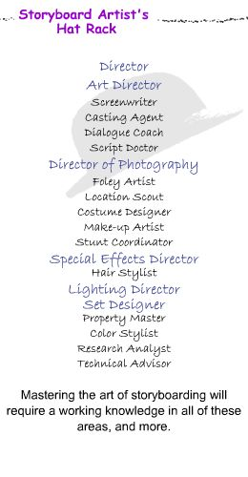
Storyboard Artist's Hat Rack
As mentioned earlier in this lecture series, the storyboard artist must wear many hats. A production company will utilize the talents of a vast array of professionals, experts, and technicians. The storyboard artist, in most cases, must be able to fill all of these roles in order to do justice to the project he or she may be assigned.
Identifying these roles almost reads like the closing credits in a major motion picture. Imagine looking at the following credits, with your name beside each one of them.
This brings us to the end of the lectures this week. We examined storyboarding principles, techniques, and procedures. We also saw how successful professionals have applied these concepts in their work. Your active work starts here. As you complete your assignments, make sure that you apply the concepts from the lectures and from the textbook. Also participate as much as you can in the discussions and critique sessions. Remember the ability to give and take feedback positively is an essential element of teamwork. And your work will improve dramatically if you take the feedback seriously.

Assignment 1: Autobiography
Sketch at least 5 key events in your life and present them in the form of a storyboard. By Tuesday, January 2, 1900, submit it to the appropriate Discussion Area. Review and comment on the autobiographies of other students by the end of the week.
Visit the following URL for examples of storyboards:
- http://www.anthonyzierhut.com
- http://www.storyboards-east.com/storybrd.htm
Assignment 1 Grading Criteria and Respective Point Value | Maximum Points
Drew sketches that depict events clearly | 4
Included enough panels to tell the story | 4
Demonstrated graphic communication skills | 4
Total: | 12
For assistance with any problems you may have when completing this assignment—OR—to offer your assistance to classmates, please use the Problems and Solutions Discussion area located through the left side navigation link.
Start to think about 'point of view' in this assignment and don't necessarily rely on one view in your frames. Notice that detail in some of the frames (examples) really tell a great deal about the story.

Assignment 2: Discussion Questions
By Tuesday, January 2, 1900, respond to the discussion questions assigned to you by the facilitator. Submit your responses to the appropriate Discussion Area. Start reviewing and responding to your classmates as early in the week as possible. Be clear and concise in your comments.
Assignment 2 Grading Criteria and Respective Point Value | Maximum Points
Response Criteria
Met the criteria for the correct responses to the questions assigned | 4
Used vocabulary relevant to the current week's topics - at least four terms | 4
Participation Criteria
Used vocabulary relevant to the current week's topics - at least four terms | 4
Participated in the discussion by asking a question, providing a statement of clarification, providing a point of view with rationale, challenging a point of discussion, or making a relationship between one or more points of the discussion | 4
Justified ideas and responses by using appropriate examples and references from texts, websites, and other references or personal experience | 4
Total: | 20
For assistance with any problems you may have when completing this assignment—OR—to offer your assistance to classmates, please use the Problems and Solutions Discussion area located through the left side navigation link.
Please answer any two from 2,3,or 4. 4 is similar to 1 so I would rather you answer from those 3. Again remember to also respond to two students as well.

Assignment 3: Synopsis Exercise
Think of a small story that can be told by a 30 sec - 1 min animated sequence. Write a synopsis of this story including the basic elements of storytelling as described in the lectures. By Thursday, January 4, 1900, post the synopsis to the appropriate Discussion Area.
Assignment 3 Grading Criteria and Respective Point Value | Maximum Points
Described the basics of storytelling in synopsis | 4
Established the opening | 4
Presented a conflict | 4
Reached obvious closure | 4
Total: | 16
For assistance with any problems you may have when completing this assignment—OR—to offer your assistance to classmates, please use the Problems and Solutions Discussion area located through the left side navigation link.
Again try to keep this simple but pay attention to small details as they can tell a powerful story.

Assignment 4: Thumbnail Storyboard Exercise
Early in the week, the facilitator will assign a synopsis to you for creating rough thumbnail boards to establish visual direction. Create the thumbnail boards, scan them, and post them to the appropriate Discussion Area, by Saturday, January 6, 1900.
Review and critique the thumbnail boards of the student to whom your synopsis was assigned and provide feedback on how well your idea was captured by the end of the week. Also suggest improvements.
Assignment 4 Grading Criteria and Respective Point Value | Maximum Points
Designed thumbnail board to follow the synopsis | 4
Ensured flow and continuity in the thumbnail board | 4
Provided enough panels in thumbnail board to tell the story | 4
Indicated appropriate camera positions in thumbnail board | 4
Provided valid and meaningful comments | 4
Total: | 20
For assistance with any problems you may have when completing this assignment—OR—to offer your assistance to classmates, please use the Problems and Solutions Discussion area located through the left side navigation link.
This is the first chapter of 'A Series of Unfortunate Events,' I would like you to use this as the story for your boards. The link for chapter 1 is: http://browseinside.harpercollins.com/index.aspx?isbn13=9780064407663

